Miscellaneous Software Modules
The following document contains the configuration and setup information for a group of optional Control Modules.

Confidential/Proprietary Statement
This document contains trade secrets and information that is considered confidential and proprietary to Fortna, Inc. It may not be duplicated, used, or disclosed outside the original recipient organization, and it may not be duplicated, in whole or in part, for any purpose other than to evaluate this document. Fortna Material Handling reserves the right to modify this document as necessary to reflect any terms and conditions negotiated and included as part of a subsequent contract or purchase order.

High Speed Pusher Module (HSPusher)
The HSPusher Module is used to send a “pulse” of a specific time duration to a High Speed Pusher to trigger it to cycle. This is needed in particular with certain varieties of pusher that “lock-up” if the output is held high for too long.

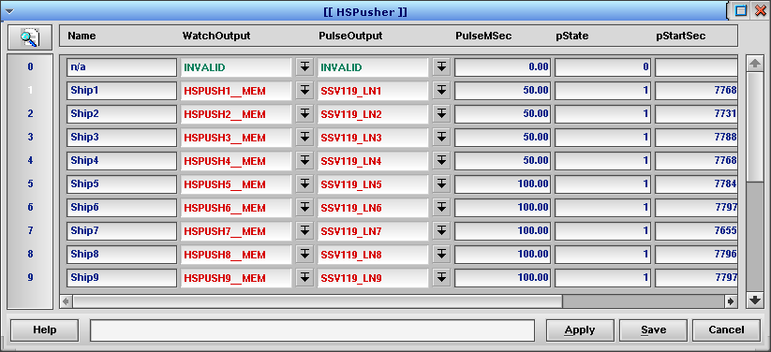

The fields in the HSPusher table are:

Name – Description for the record.

WatchOutput – Pop-up selects the I/O to watch for a off/on transition.

PulseOutput – Pop-up selects the output that should pulse for the given duration.

PulseMSec – The number of milliseconds to turn on the PulseOutput.

pState – Program controlled value showing the state (numeric) of this record.

pStartSec, pStartNSec – Program controlled values storing the moment the pulse started.

LogLevel – Set to 0 to turn off logging; set to 1 to turn on state transition logging.

The HSPusher Module executes the following logic for each record:

WatchOut is ON
WaitForOn
Unfire PulseOut
Done Timing
Active
Fire PulseOut
WatchOut is OFF
WaitForOff
Unfire PulseOut
The numeric states that are shown in the pState field are:
0 = NotUsed
1 = WaitForOn
2 = Active
3 = WaitForOff

Please note that the HSPusher module uses FIRE and UNFIRE to control the PulseOutput. This I/O should, therefore, not be used in any other modules that use FIRE and/or UNFIRE to control outputs.

The typical application of this module would be to configure a Memory I/O for each High Speed Pusher that needs to be controlled and put this Memory I/O in the Outputs table of the appropriate sorter. Configure the Memory I/O as the WatchOutput and configure the real High Speed Pusher output in the PulseOutput field. In this way, whenever the sorter fires the Memory I/O, a pulse of PulseMSec duration will be activated on the PulseOutput.

